## A REPORT ON

**COLLEGE NEWS FEED**

SUBMITTED TO THE SAVITRIBAI PHULE PUNE UNIVERSITY, PUNE IN THE PARTIAL FULFILLMENT OF THE REQUIREMENT OF

**PROJECT BASED LEARNING (FIRST YEAR ENGINEERING)**

## SUBMITTED BY

|  |  |
| --- | --- |
| STUDENT NAME: | PRN No. |
| Anushna Panwar | 72285703K |
| Divya Prakash | 72285753F |
| Prayas Poonia | 72285876M |
| Sumit Kumar Beniwal | 72285960M |
| Vivek Singh | 72285994F |

**DEPARTMENT OF ASGE**

## ARMY INSTITUTE OF TECHNOLOGY

DIGHI HILLS, ALANDI ROAD, PUNE 411015

**SAVITRIBAI PHULE PUNE UNIVERSITY 2020 -2021**



# CERTIFICATE

This is to certify that the project report entitled **“COLLEGE NEWS FEED” SUBMITTED BY**

|  |  |
| --- | --- |
| STUDENT NAME: | PRN No. |
| Anushna Panwar | 72285703K |
| Divya Prakash | 72285753F |
| Prayas Poonia | 72285876M |
| Sumit Kumar Beniwal | 72285960M |
| Vivek Singh | 72285994F |

are bonafide students of this institute and the work has been carried out by them under the supervision of **Dr.B.P.Patil** and it is approved for the partial fulfillment of the requirement of, First year course on Project Based learning of Savitribai Phule Pune University.

## (Dr. B.P. Patil) (Prof. Dr. S. A. Kulkarni)

Guide Head,

Department of ASGE Department of ASGE

Place : Pune

Date:

## (Dr. B.P. Patil)

Principal,

Army Institute of Technology, Dighi, Pune – 411015

# ACKNOWLEDGEMENT

We would like to use this opportunity to thank our team members. Without them this project would not have been possible. Their support and cooperation played a pivotal role in the success of this project.

We would like to express our special thanks to our guide and supervisor, Dr. B. P. Patil, who gave us the golden opportunity to do this wonderful project on the topic “College News Feed”, which also helped us in doing a lot of Research and We came to know about so many new things. We are really thankful to him.

We would also like to thank our college and university for providing such a nice platform to learn, understand and implement our ideas.

**Name of Students:**

Anushna Panwar

Divya Prakash

Prayas Poonia

Sumit Kumar Beniwal

Vivek Singh

# **ABSTRACT**

In computing, a web application or web app is a client–server software application which

the client or user runs in a web browser. Web applications are getting popular these days

as they can be accessed from anywhere using a web browser and the convenience of using

a web browser as a client to update and maintain web applications without distributing and

installing software.

In this project an online College News platform will be created for the Institution as part of this project. To develop a platform where students can collectively get all the important notices and news of AIT.

This will keep college students updated about all important notices , news , events and achievements of students. also providing contact details of administration and student council. There will also be a separate section for lost and found. The major goal of this project is to help the students around the campus with a web service to find their lost stuff more quickly. The application is an online lost and found web portal with an interactive user interface. It is a user-friendly web application which is created using web programming languages connected to the

database.

There has been a major drawback to the overall development of the student by the absence of a platform where all the students get updates regarding the latest events, News, and Achievements in AIT. Through this project, we wish to provide a Legit Lost and Found Portal for students and staff. The major goal of this project is to help the students around the campus with a web service to find their lost stuff more quickly. The application

is an online lost and found web portal with an interactive user interface. It is a user-friendly

web application which is created using web programming languages connected to the

database. The project is designed using a client-server model.

This project consists of developing an entirely new website, using basic programming techniques, cascading, styling, and database languages.

TABLE OF CONTENTS

|  |  |  |  |  |  |
| --- | --- | --- | --- | --- | --- |
| **Sr. No.** | | | **Title of Chapter** | | **Page No.** |
| **01** | | | **Introduction** | | 6 |
|  | | 1.1 | Overview | | 6 |
|  | | 1.2 | Motivation | | 6 |
|  | | 1.3 | Problem Definition and Objectives | | 6 |
|  | | 1.4 | Project Scope & Limitations | | 7 |
|  | | 1.5 | Methodologies of Problem solving | | 7 |
| **02** | | | **Literature Survey** | | 8 |
| **03** | | | **Web/UI Design** | | 9 |
|  | | 3.1 | Data Flow Diagrams | | 9 |
|  | | 3.2 | User-Interface Design | | 10 |
|  | | 3.3 | Code screenshots | | 15 |
| **04** | | | **Project Plan** | | 17 |
|  | | 4.1 | Project Resources | | 17 |
|  | | 4.2 | Project Schedule | | 17 |
|  | |  | 4.2.1 | Timeline Chart | 17 |
|  | | 4.3 | Team Organization | | 18 |
|  | |  | 4.3.1 | Team structure | 18 |
| **05** | | | **Project Implementation** | | 19 |
|  | | 5.1 | Overview of Project Modules | | 19 |
|  | | 5.2 | Tools and Technology Used (Tech Stack) | | 20 |
|  | |  | 5.2.1 | HTML | 20 |
|  | |  | 5.2.2 | CSS | 21 |
|  | |  | 5.2.3 | JavaScript | 22 |
|  | |  | 5.2.4 | Firebase | 22 |
|  | |  | 5.2.5 | Bootstrap | 24 |
| **06** | | | **Results** | | 25 |
|  | 6.1 | | Students’ awareness of upcoming events | | 25 |
|  | 6.2 | | Important updates with the help of our site | | 25 |
|  | 6.3 | | Lost and found portal | | 26 |
| **07** | | | **Conclusions** | | 27 |
|  | | 7.1 | Conclusions | | 27 |
|  | | 7.2 | Future Work | | 27 |
|  | | | **References:** Internet Links | | 28 |
|  | | | **Appendix:** Plagiarism Report of project report. | | 29 |

1.Introduction

**1.1 OVERVIEW**

The growing significance of websites for various organizations is well known. In recognizing that we decide to develop a website for the college which compromises of all the required information about the college.The purpose of our project is to design, publish and maintain a website for our college which consists of all the information regarding the college like Events, News, ECA etc. important messages and notifications can be forwarded to the students. This will help in increasing student’s awareness regarding ongoing events in college.

**1.2 MOTIVATION**

It has been observed that in the online mode of instruction the involvement of students in ECA has been decreased. Most of the students are even not aware of the ongoing hackathons and tech-events and various other activities that are organized in the institution. This has led to a decline in the students’ participation in ECA and thus, limits his all-round development.

* 1. **PROBLEM DEFINITION and OBJECTIVES**

The existing AIT website is a multi-purpose website it has a lot of sections like Branch details, alumni applications for new admissions, etc. Due to this students find it difficult to browse for new notices, current ongoing events. Also there is not any common platform for students and staff for lost and found purpose. Also students have been less likely to participate in ECAs. Students are unaware of the ongoing hackathons, tech events, and various other events organized by the institution.

We are creating a website which will be focused only on latest news, notices, events and common platform for Lost and found. This website will be Convenient and User friendly website Notified about all the events and notices One place to get all forms , records of events, contacts & deadlines legit lost and found portal.

**1.4 PROJECT SCOPE AND LIMITATIONS**

There are numerous technical events, hackathons, and other activities that are organized within the institution that are unknown to most students. The students have subsequently stopped participating in ECA, thereby limiting their overall development. WhatsApp is primarily used to deliver important notices, which can only be accessed by phone (or by PC if connected to phone) and in the event the phone malfunctions, students may miss important information.

There are only a few limitations in our project that we plan to address in future, such as lack of Authenticity, small server to store all the past and present data and Website management team. We are also forced to clear the data (including messages, photos, videos, and files) after a certain period of time due to the less storage. So, at the moment, the storage capacity of our website is a major constraint.

**1.5 METHODOLOGIES OF PROBLEM SOLVING**

In order to ensure all alumni, college staff and fellow mates are able to communicate and share ideas and thoughts on a website, we will be creating one.

Additionally, we will have a notification panel so that we can forward important messages and notifications.

We will also have a Feed to keep you updated on all club events and ongoing activities. Our college website, Facebook page, Insta page for specific clubs, and other basic announcements are available on different platforms, so we would like to integrate them in one.

2.Literary Survey

Various platforms have been proposed for the solution of this problem.

Ultimately, Facebook's purpose is to connect people with their friends and family. People use Facebook to share photos, videos, and general updates on their lives.

Twitter, on the other hand, is used to share ideas, real-time information, and trending news. While people may also use Twitter to connect with friends and family, they largely use it for a bigger purpose -- to connect to the wider world as a whole, and hear what's happening.

And then, Instagram is used to share photos and videos. People mainly use this app to post their "highlight reel" and follow influencers. This is where people become a part of a social media community.

LinkedIn is different from the rest of the social media outlets because it’s specifically designed for business and professionals. Users mainly go to LinkedIn to showcase their job experience and professional thoughts, making it one of the more important platforms to use for those in B2B.

In conclusion, none of the known platforms provide account authentication, and this server would only be used by one institution, so there would be no interference from other institutions or groups.

While many patents have been filed with various solutions, none serve this purpose of integrating all platforms in one.

3. WEB/UI DESIGN

**3.1 DATA FLOW DIAGRAM**

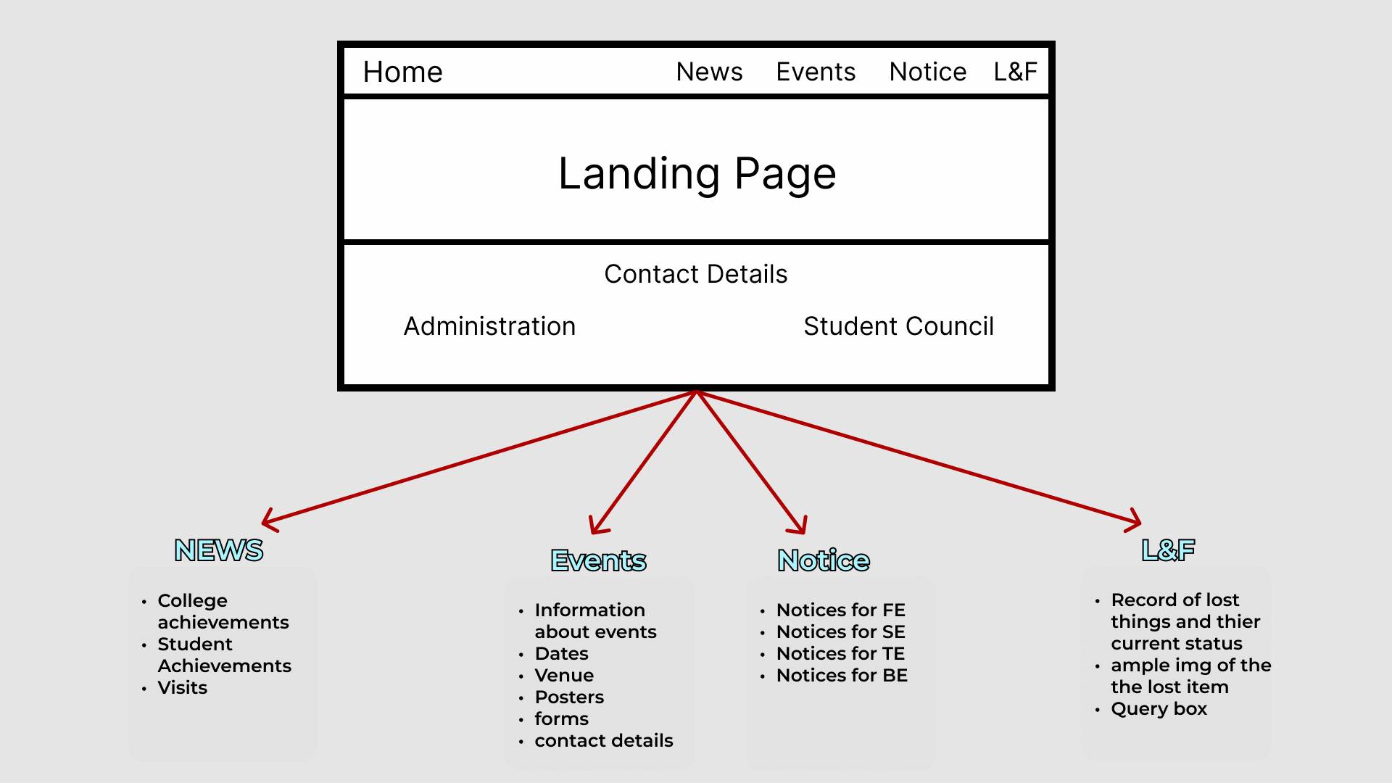

3.2 USER INTERFACE DESIGN

1. Home Page

1. News Section

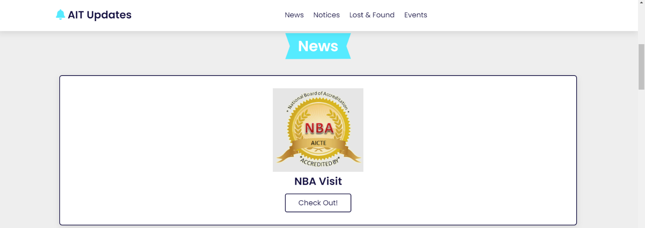

1. Lost & Found Section

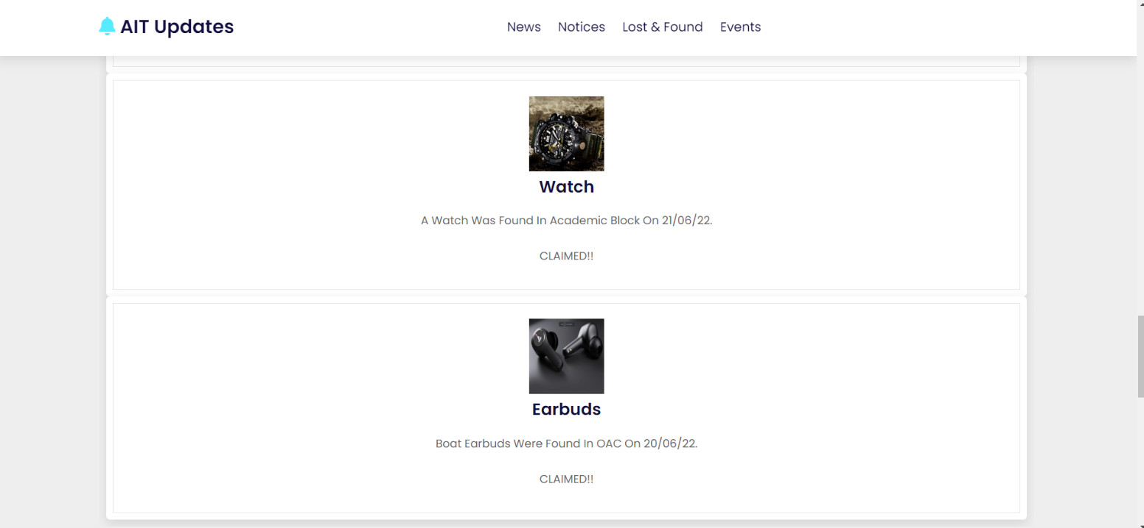

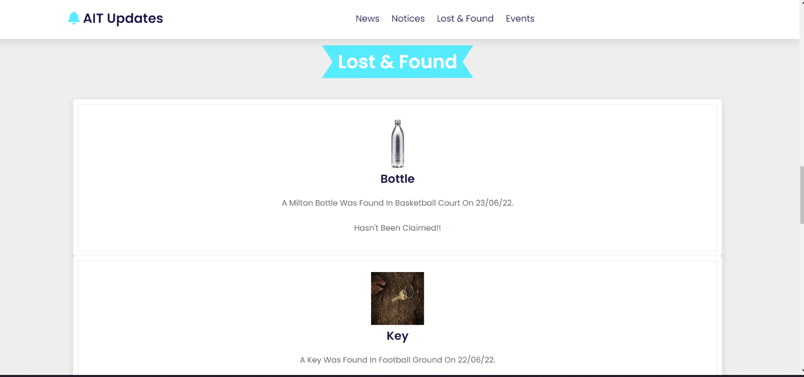

1. Events Section

6) Information Section

3.3 CODE SCREENSHOTS

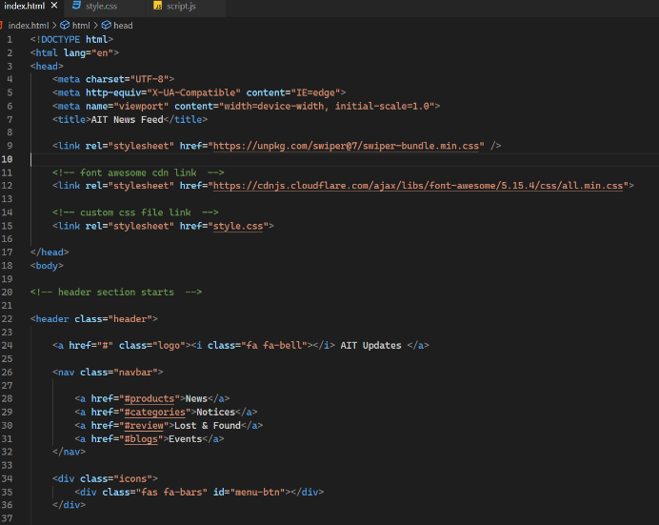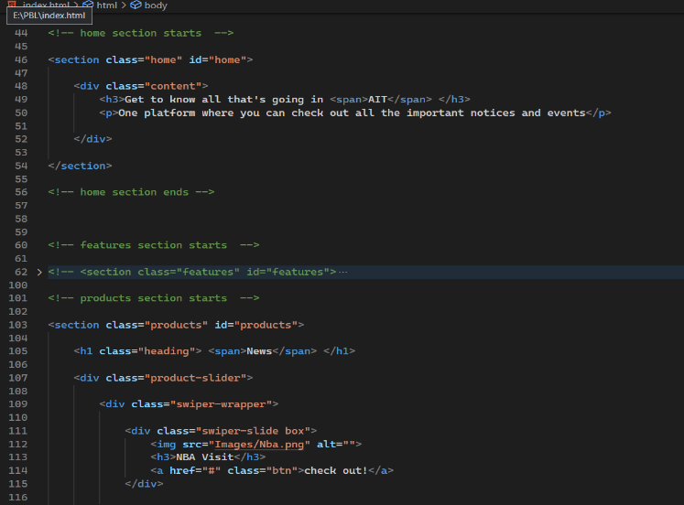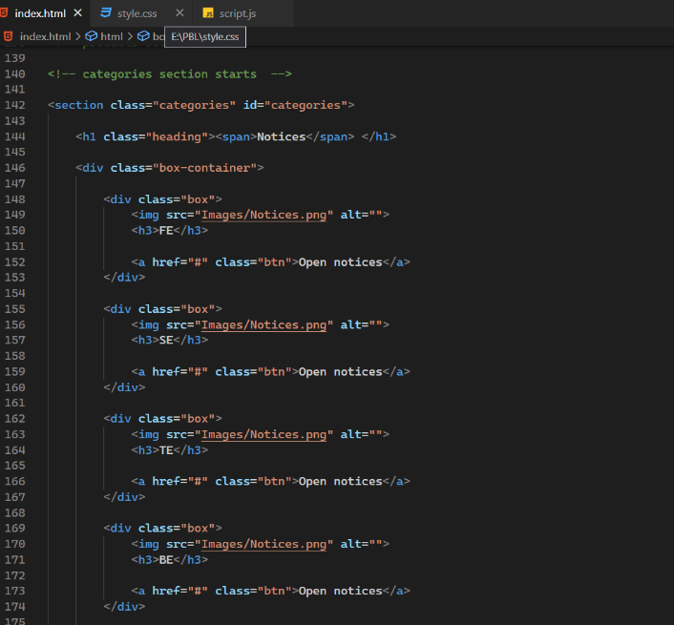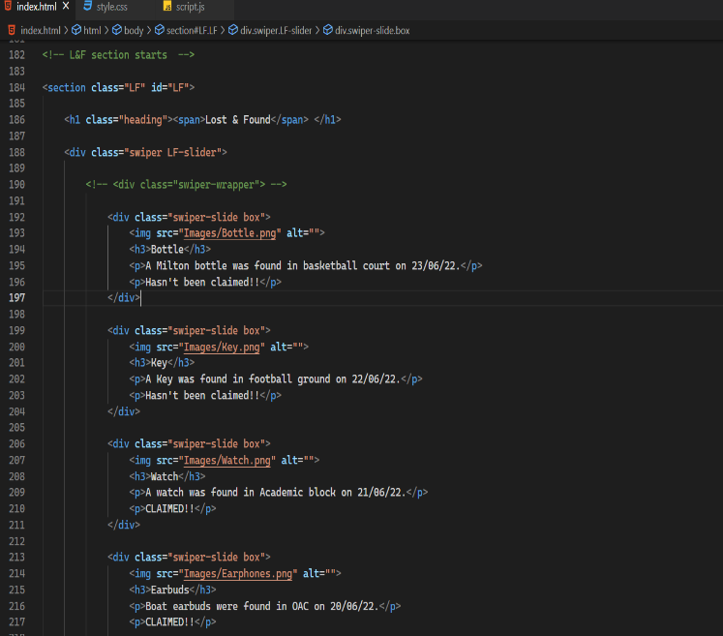

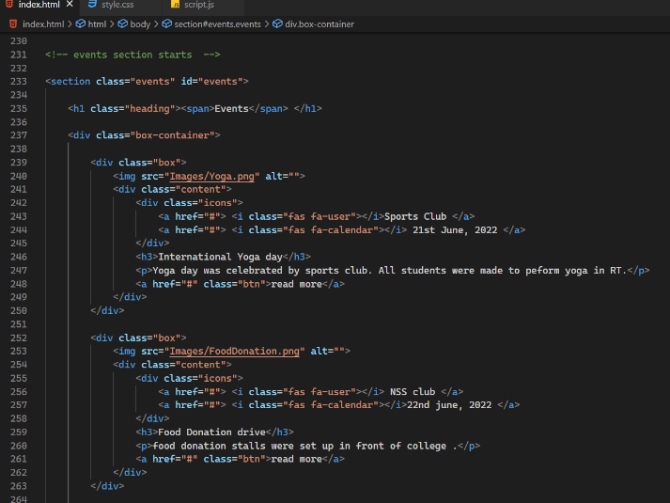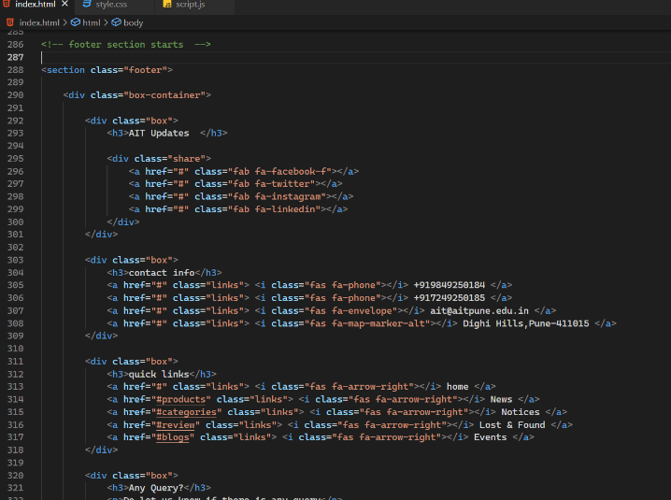

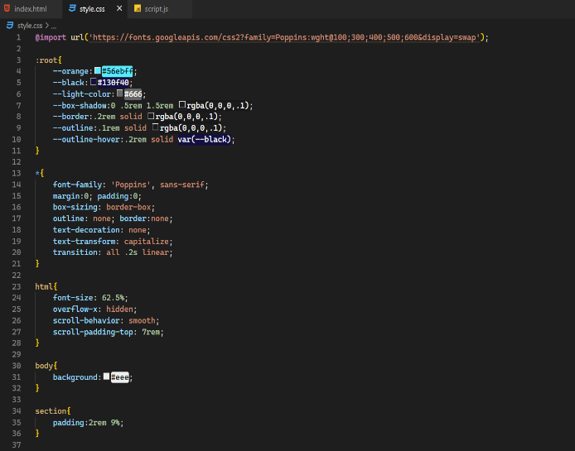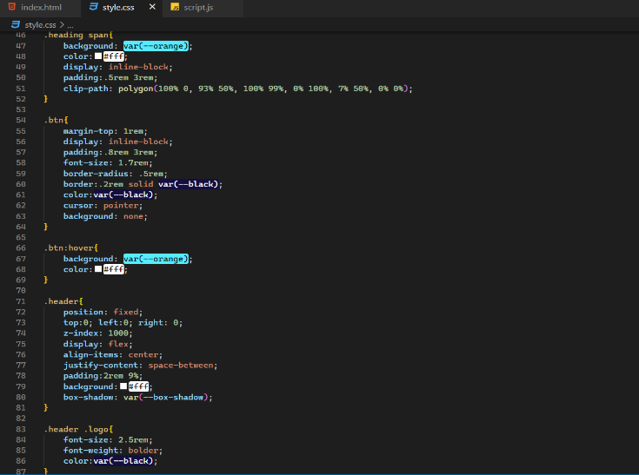

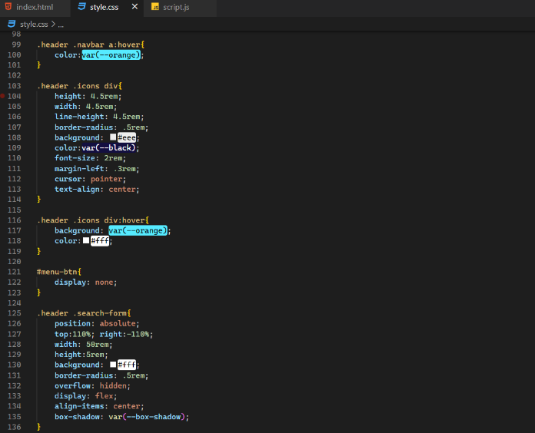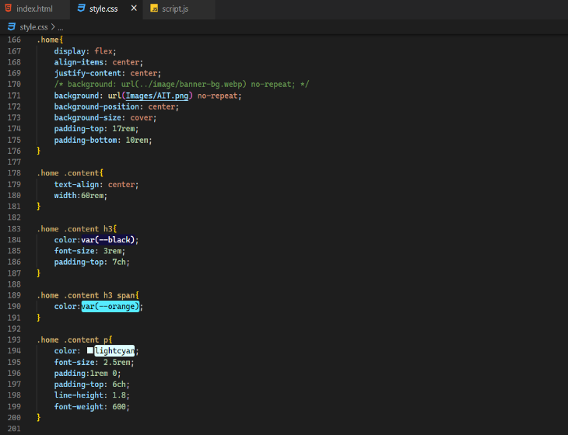

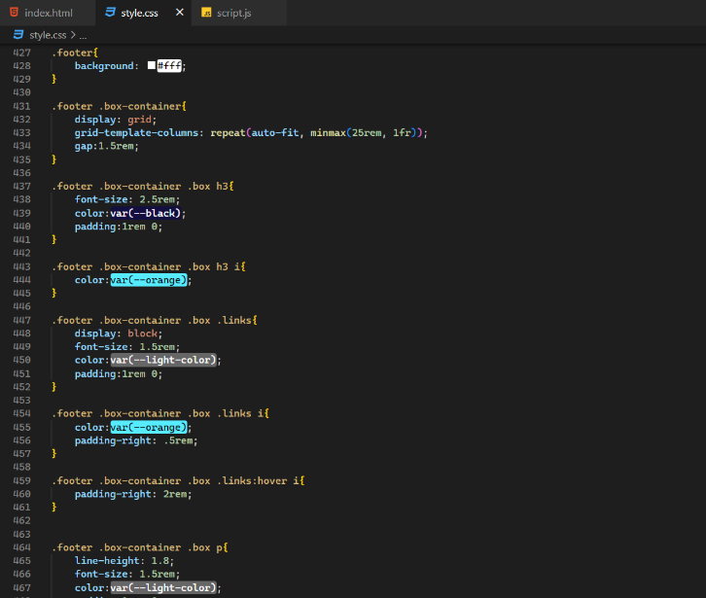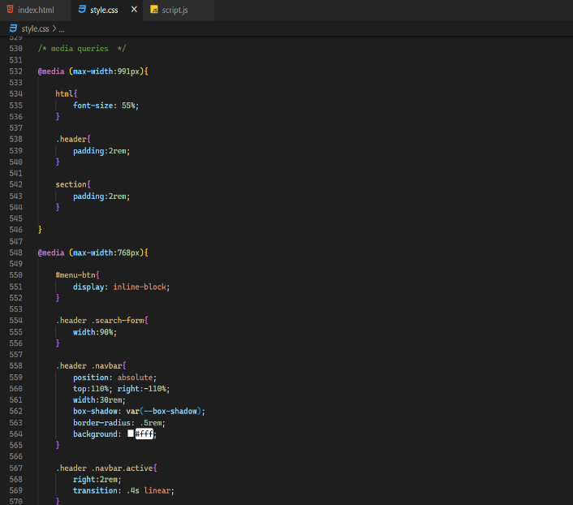

**4. PROJECT PLAN**

**4.1 PROJECT RESOURCES**

Various Resources were used for understanding the working of Backend and Frontend together. Links for different websites used are given in References. Some of the Resources are as follows:

1. Websites used for learning HTML/CSS: w3schools.com, developer.mozilla.org.

2. Udemy Courses: JavaScript, Bootstrap, HTML/CSS, Firebase

**4.2 PROJECT SCHEDULE**

4.2.1 Timeline Chart

|  |  |
| --- | --- |
| **Week** | **Progress** |
| Week 1 | Discussions on what PBL is about and discussion on the project. |
| Week 2 | Finalized our project topic (Making a Website for Updates of AIT). |
| Week 3 | Gave a PowerPoint presentation on our topic. |
| Week 4 | Divided the project into different parts and decided who is going to work on which part. |
| Week 5 | Presented a poster on our topic and discussed the pros & cons and how we are going to make our project |
| Week 6 | Decided the UI/UX of different pages of our website i.e. how the different pages will look. |
| Week 7 | Developed the home page, news section and notice section of our website. |
| Week 8 | Developed the events section, lost & found section and information section of our website. |
| Week 9 | Compilation of the whole Project |

**4.3 TEAM ORGANIZATION**

**4.3.1 TEAM STRUCTURE**

|  |  |  |  |  |
| --- | --- | --- | --- | --- |
| S. No. | Task | Member 1 | Member 2 | Member 3 |
| 1 | UI Designing | Anushna Panwar | Sumit Beniwal | Vivek Singh |
| 2 | Frontend Dev | Anushna Panwar | Divya Prakash | Prayas Poonia |
| 3 | Backend Dev | Divya Prakash | Prayas Poonia | Sumit Beniwal |
| 4 | Data and Image collection | Vivek Singh | Prayas Poonia | Anushna Panwar |
| 5 | Database | Sumit Beniwal | Vivek Singh | Divya Prakash |
| 6 | Report Making | Prayas Poonia | Divya Prakash | Sumit Beniwal |

Team has been divided in the following manner:

# **5.PROJECT IMPLEMENTATION**

## OVERVIEW OF PROJECT MODULES

Based on the stack used, we can divide the project modules as follows:

HTML, CSS, Bootstrap: Creating and displaying a dynamic UI for the application

MongoDB: An open-source NoSQL database

Firebase: For backend and connecting database and frontend

JavaScript: To make a responsive site

Taking a high-level approach

Building the user interface of our website

Render HTML dynamically by setting up your server.

Connection of database to the server and building models for the database.

## TOOLS AND TECHNOLOGIES USED

The technologies and the tools behind this project are simple by use and abundant by quantity. Those are as follows:

* + 1. **HTML**

HTML, or Hyper Text Markup Language, is a markup language used to design documents for display on the web. The process can be aided by technologies such as Cascading Style Sheets (CSS) and scripting languages such as JavaScript. Web browsers receive HTML documents from a web server or from local storage and render the documents into multimedia web pages. Web pages are structured semantically according to HTML, which originally included cues regarding the document's appearance. The HTML element is the building block of every HTML page.

HTML constructs allow images and objects, such as interactive forms, to be embedded in the rendered page. Using HTML, you can create structured documents by indicating structural semantics for text in the form of headings, paragraphs, lists, links, quotes, and other elements. Elements in HTML are delineated by tags, which are enclosed in angle brackets.

Usage in our Project: Html is basic markup language used to make all webpage on the site. It is the basic structure of all webpages which the user interacts with.

**5.2.2 CSS**

Cascading Style Sheets (CSS) describes the presentation of a document written in a markup language such as HTML. CSS is a cornerstone of the World Wide Web, along with HTML and JavaScript. CSS is designed to separate presentation and content, including layout, colors, and fonts. This separation can improve content accessibility, provide more flexibility and control in the specification of presentation characteristics, enable multiple web pages to share formatting by specifying the relevant CSS in a separate .css file which reduces complexity and repetition in the structural content as well as enabling the .css file to be cached to improve the page load speed between the pages that share the file and its formatting. The separation of formatting from content also allows different rendering methods to render the same markup page in different styles, such as on-screen, in print, by voice (via speech-based browsers or screen readers), and on Braille-based tactile devices. Those using mobile devices can also use CSS-based alternate formats.

Usage in our Project: Whereas Html defines the basic structure CSS is used for designing the web pages. The designs are mostly set by using Bootstrap which is an open CSS which enables rapid development because of its predefined classes.

**5.2.3 JavaScript**

JavaScript is a text-based programming language that can be used both on the client and server side to create interactive web pages. Web pages are structured and styled using HTML and CSS, but engaging web pages are interactive using JavaScript. JavaScript enhances the user experience of the web page by converting it from a static page to a dynamic one. To recap, JavaScript adds behavior to web pages. JavaScript is mainly used for web-based applications and web browsers.

But JavaScript is also used beyond the Web in software, servers and embedded hardware controls. Here are some basic things JavaScript is used for:

1. Adding interactive behavior to web pages

2. Creating web and mobile apps

3. Building web servers and developing server applications

Usage in our Project: Html and CSS are used for designing webpages, but the webpages are brought to life by JS. All the frontend processing is done in JS. jQuery is extensively used for binding functions, AJAX and making page responsive.

**5.2.4 FIREBASE**

Google Firebase is a Google-backed application development software that enables developers to develop iOS, Android and Web apps. Firebase provides tools for tracking analytics, reporting and fixing app crashes, creating marketing and product experiment.

Firebase offers a number of services, including:

* Analytics – Google Analytics for Firebase offers free, unlimited reporting on as many as 500 separate events. Analytics presents data about user behavior in iOS and Android apps, enabling better decision-making about improving performance and app marketing.
* Authentication – Firebase Authentication makes it easy for developers to build secure authentication systems and enhances the sign-in and onboarding experience for users. This feature offers a complete identity solution, supporting email and password accounts, phone auth, as well as Google, Facebook, GitHub, Twitter login and more.
* Cloud messaging – Firebase Cloud Messaging (FCM) is a cross-platform messaging tool that lets companies reliably receive and deliver messages on iOS, Android and the web at no cost.
* Realtime database – the Firebase Realtime Database is a cloud-hosted NoSQL database that enables data to be stored and synced between users in real time. The data is synced across all clients in real time and is still available when an app goes offline.
* Crashlytics – Firebase Crashlytics is a real-time crash reporter that helps developers track, prioritize and fix stability issues that reduce the quality of their apps. With crashlytics, developers spend less time organizing and troubleshooting crashes and more time building features for their apps.
* Performance – Firebase Performance Monitoring service gives developers insight into the performance characteristics of their iOS and Android apps to help them determine where and when the performance of their apps can be improved.
* Test lab – Firebase Test Lab is a cloud-based app-testing infrastructure. With one operation, developers can test their iOS or Android apps across a variety of devices and device configurations. They can see the results, including videos, screenshots and logs, in the Firebase console.

**5.2.5 BOOTSTRAP**

Bootstrap is an HTML, CSS & JS Library that focuses on simplifying the development of informative web pages (as opposed to web apps). The primary purpose of adding it to a web project is to apply Bootstrap's choices of color, size, font and layout to that project. As such, the primary factor is whether the developers in charge find those choices to their liking. Once added to a project, Bootstrap provides basic style definitions for all HTML elements. The result is a uniform appearance for prose, tables and form elements across web browsers. In addition, developers can take advantage of CSS classes defined in Bootstrap to further customize the appearance of their contents. For example, Bootstrap has provisioned for light- and dark-colored tables, page headings, more prominent pull quotes, and text with a highlight.

Bootstrap also comes with several JavaScript components which do not require other libraries like jQuery. They provide additional user interface elements such as dialog boxes, tooltips, progress bars, navigation drop-downs, and carousels. Each Bootstrap component consists of an HTML structure, CSS declarations, and in some cases accompanying JavaScript code. They also extend the functionality of some existing interface elements, including for example an auto-complete function for input fields.

**6. RESULTS**

**6.1 Students' awareness of upcoming events:**

Our project facilitates the sharing of important notifications regarding official events or club- related events.

In the feed section, official notifications will be given the highest priority. In other words, the official notices will appear at the top of the feed. The club events will be the second priority following this. We were able to keep a record of important data easier since the website was centralized to our institution only. This means that the chances of any student missing the information are extremely slim. Additionally, events can be displayed with their results. Students are thus encouraged to get involved in fields of interest and become enthusiastic about them.

As a result, our website is not just a tool for offering notices and raising awareness but will surely play an active role in encouraging students to be involved in extracurricular activities and in increasing their overall growth.

**6.2 You won't miss important updates with the help of our site:**

As we will have a notification panel, updates regarding not only events, but also academics- related notifications will be forwarded on the same. We will also have a Feed so that you can keep up to date with all club activities and events.

This eliminates the need for students and employees to check other platforms like Facebook. WhatsApp, Instagram, etc.

**6.3 Lost and found Portal:**

There will be a separate lost and found portal on our website which will help students and staff to track there lost belonging in the campus easily, the just have visit the website, and in the lost and found section they can get info about there just by scrolling.

**7. CONCLUSION**

**7.1 Conclusions:**

We were able to complete the project by putting the best of us. We are sure that the project will be a good one and have a good scope in the professional sector. It is a sure thing that this project can integrate different platforms in a single entity.

Its main advantage is that it will give reminders about upcoming events to students, faculty, staff and other members of the institution.

## FUTURE WORK

We will continue to improve the project and include other features such as: channels to provide study material, daily feed, write-ups about various social issues, and the ability to search by topic. Not only can they explore the content, but they can also contribute innovative ideas and get guidance for executing them.

In our plans for the website, we will include exhibits of the students' talents as well as the skills of the staff members.

To create a special cloud storage system to store notes and recorded lectures for all to use.

**REFERENCES**

The following web pages were referred:

<https://en.wikipedia.org/wiki/Bootstrap>

<https://en.wikipedia.org/wiki?curid=9176510>

<https://en.wikipedia.org/wiki?curid=33139>

<https://en.wikipedia.org/wiki?curid=8785676>

<http://dx.doi.org/10.1155/2016/1391594>

<https://www.mdpi.com/2079-4991/9/8/1111>

<https://en.wikipedia.org/wiki?curid=42507412>

[http://journal.frontiersin.org/Journal/10.3389/...](http://journal.frontiersin.org/Journal/10.3389/fninf.2014.00042/full)

INTERNET LINKS:

1. <https://developer.mozilla.org/en-US/docs/Learn/Server-side/Introduction>

2.https://en.wikipedia.org/wiki/CSS

3.https://en.wikipedia.org/wiki/HTML

4. https://www.hackreactor.com/blog/what-is-javascript-used-for

**APPENDIX**

## PLAGIARISM REPORT

Following Report has been obtained from the [PaperRater](https://www.paperrater.com/) website.

It is a trustable website for checking the originality of the work.

Our project work has been verified as free from plagiarism.

